**The Root of All Types: *System.Object***

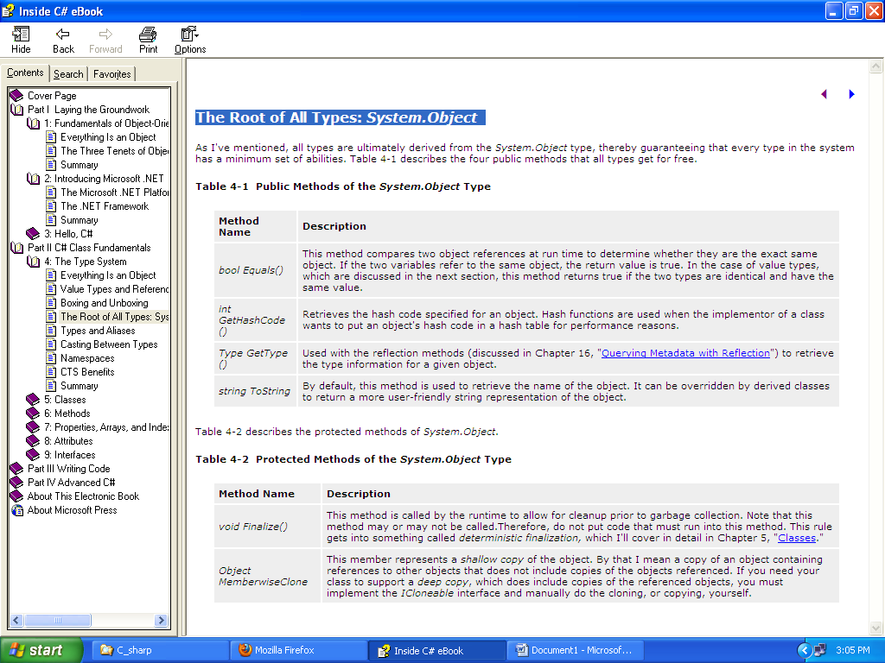

# Types and Aliases

While the CTS is responsible for defining the types that can be used across .NET languages, most languages choose to implement aliases to those types. For example, a four-byte integer value is represented by the CTS type *System.Int32*. C# then defines an alias for this called *int*. There is no advantage to using one technique over the other. Table 4-3 lists the different CTS types and their C# aliases.

